**Module 4 Activity 1: Protecting Resources**

Anudeep Anisetty

Information Technology, Arizona State University

IFT 554: Middleware Prog & Database Sec

Dinesh Sthapit

March 3, 2024

**Module 4 Activity 1: Protecting Resources**

1. **Screenshot Requirement**: Terminal showing successful installation of dependencies.

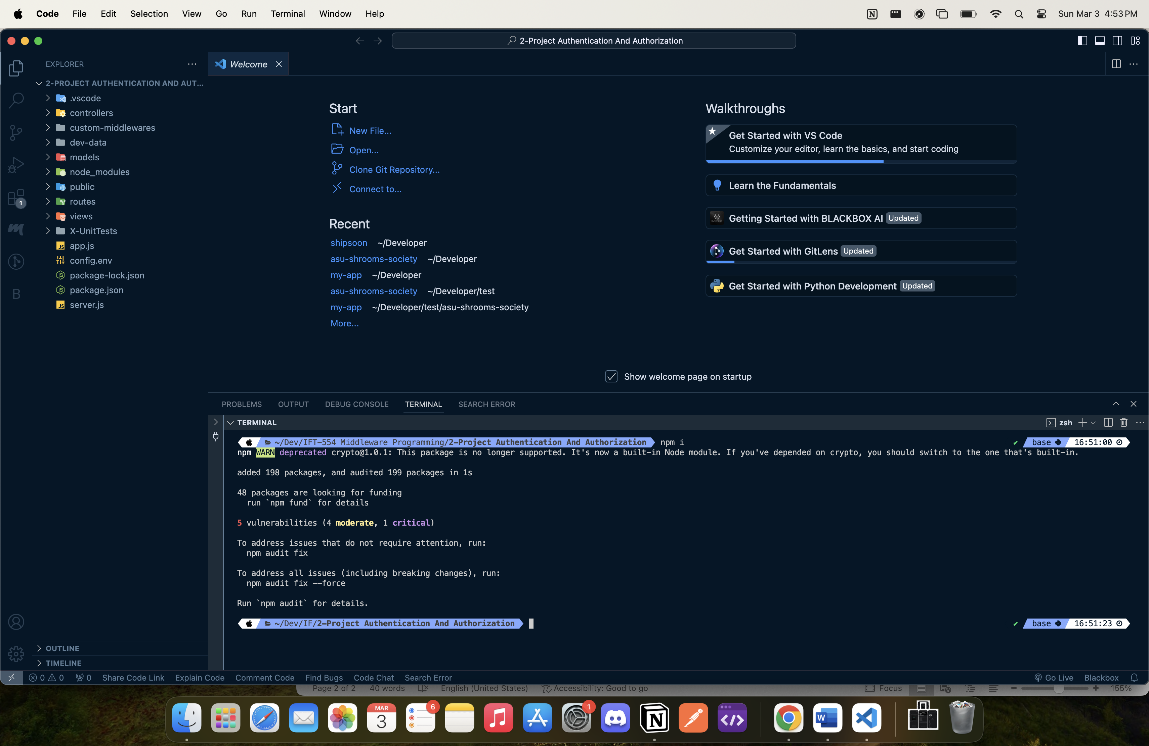

1. **Screenshot Requirement**: Capture a screenshot of the Debug Terminal.

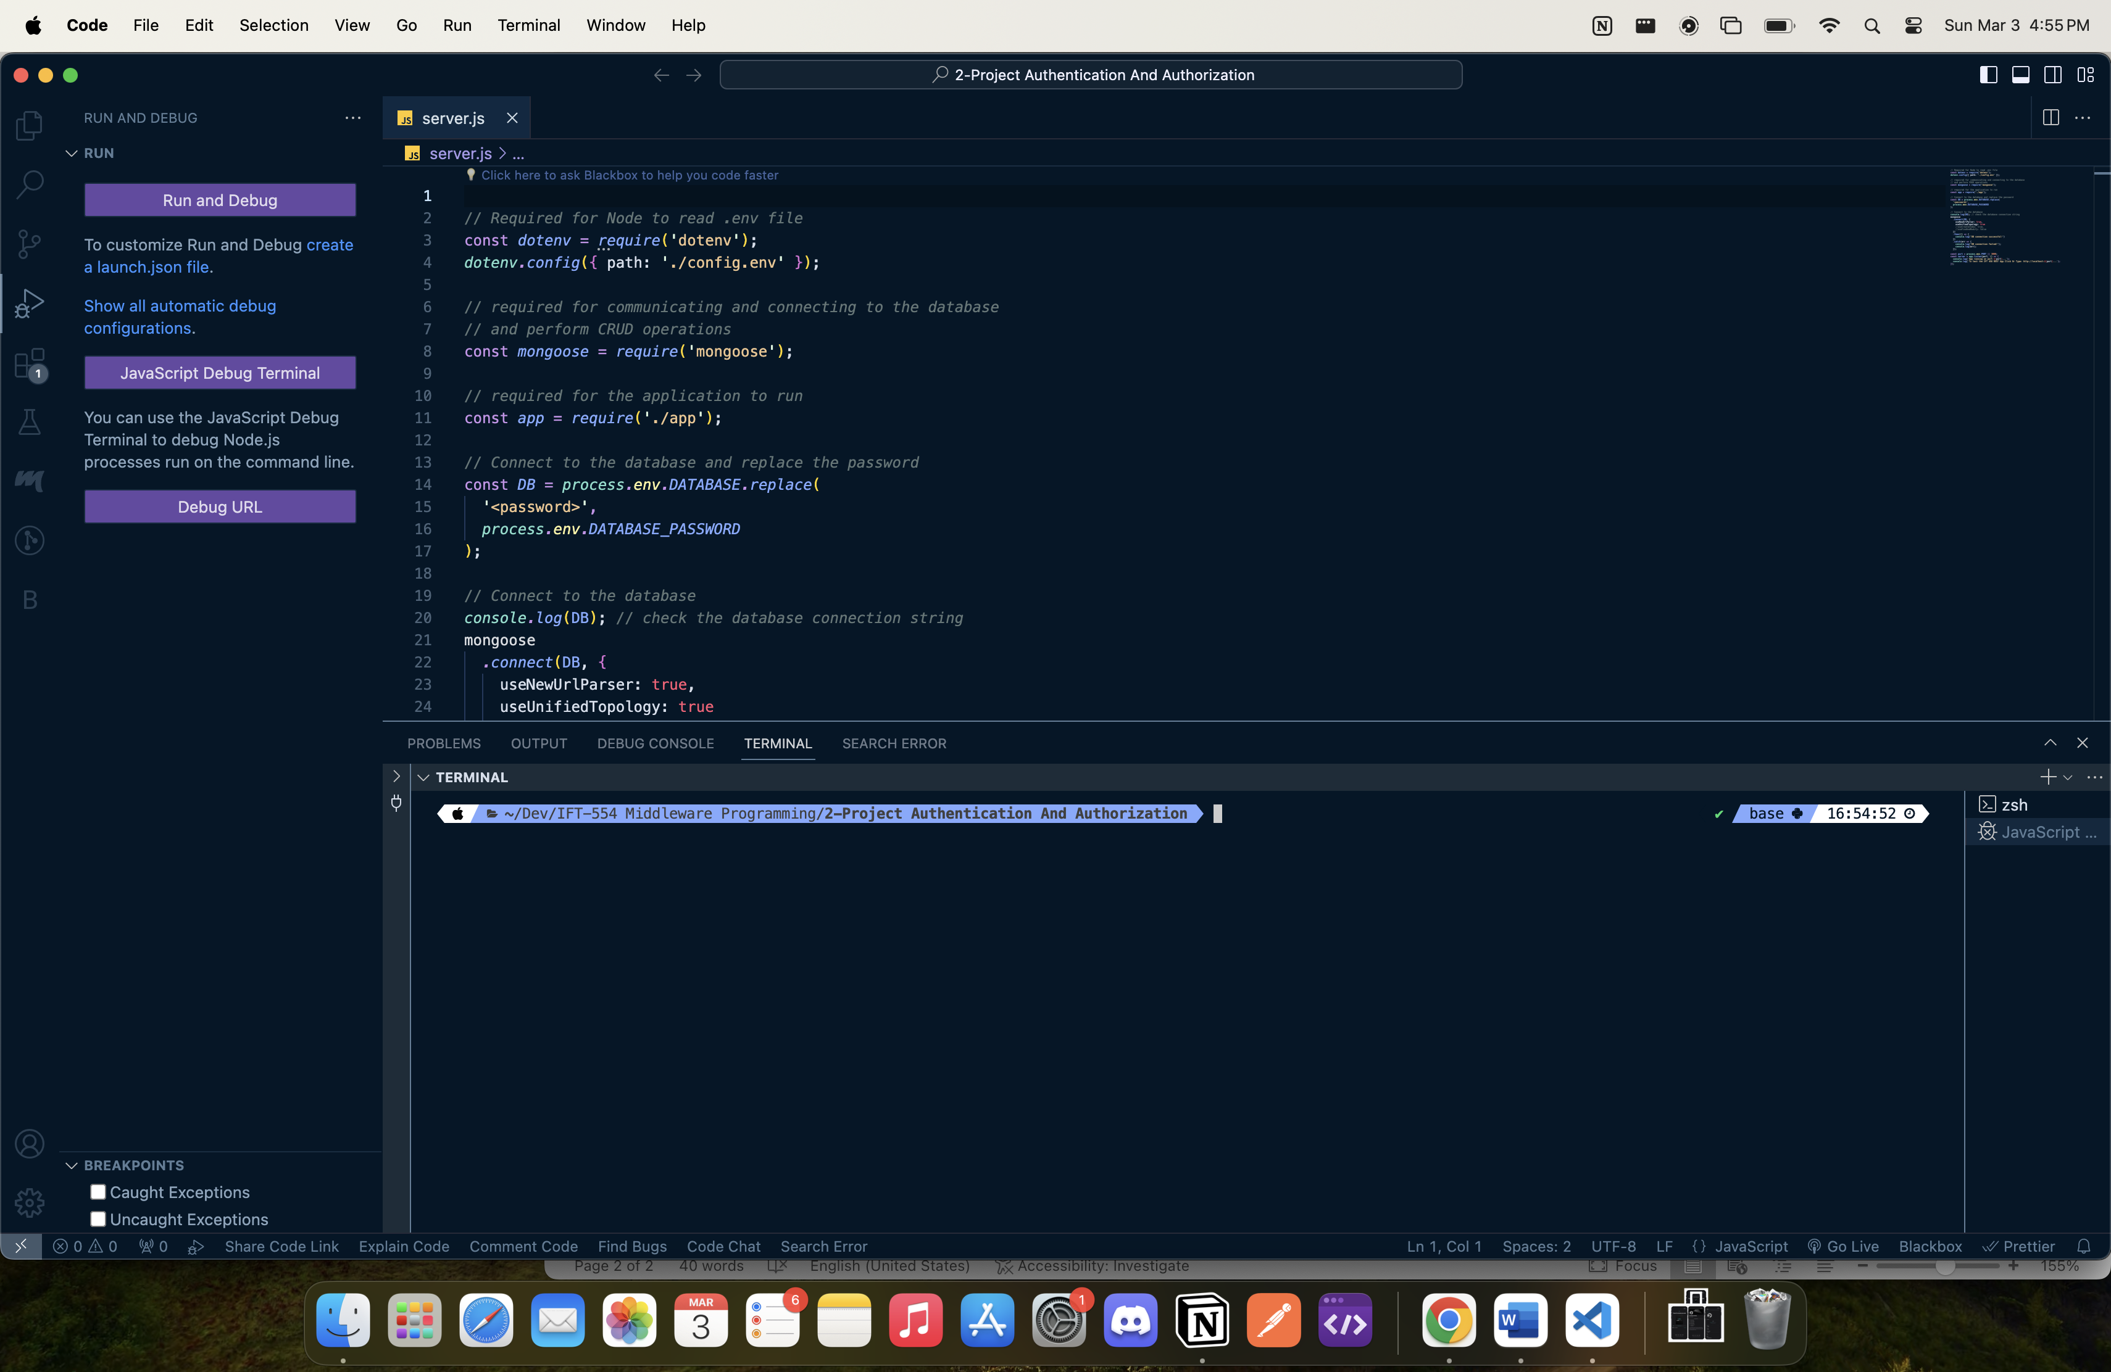

1. **Screenshot Requirement**: Capture a screenshot showing the breakpoints.

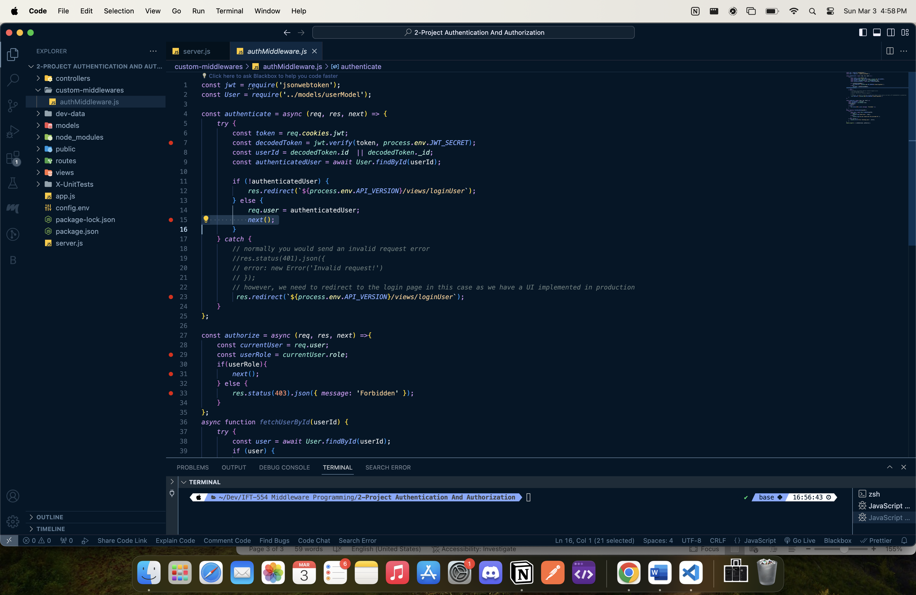

1. **Screenshot Requirement**: "Debugger Attached" message in the terminal.

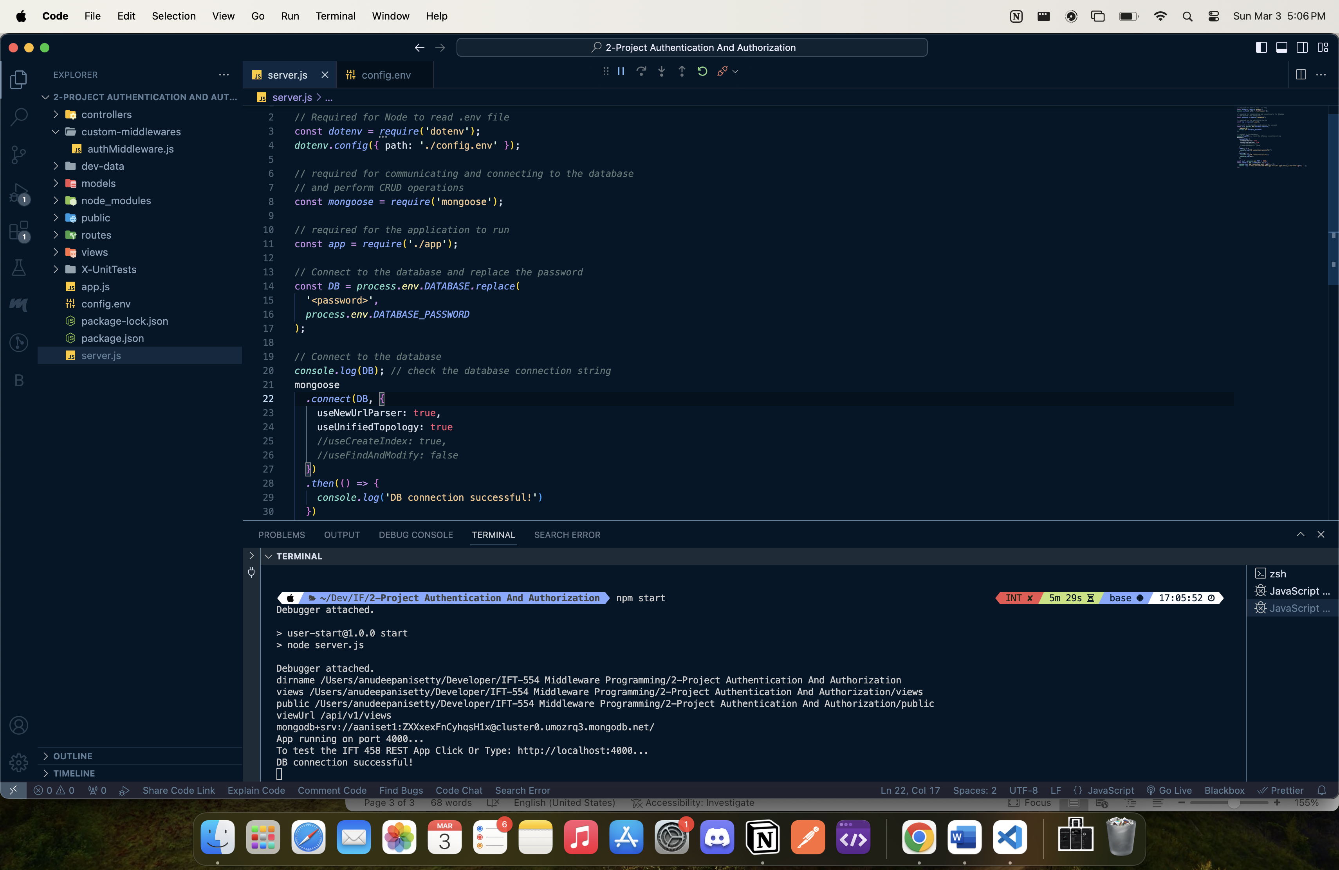

1. **Screenshot Requirement**: Homepage of the application in the browser.

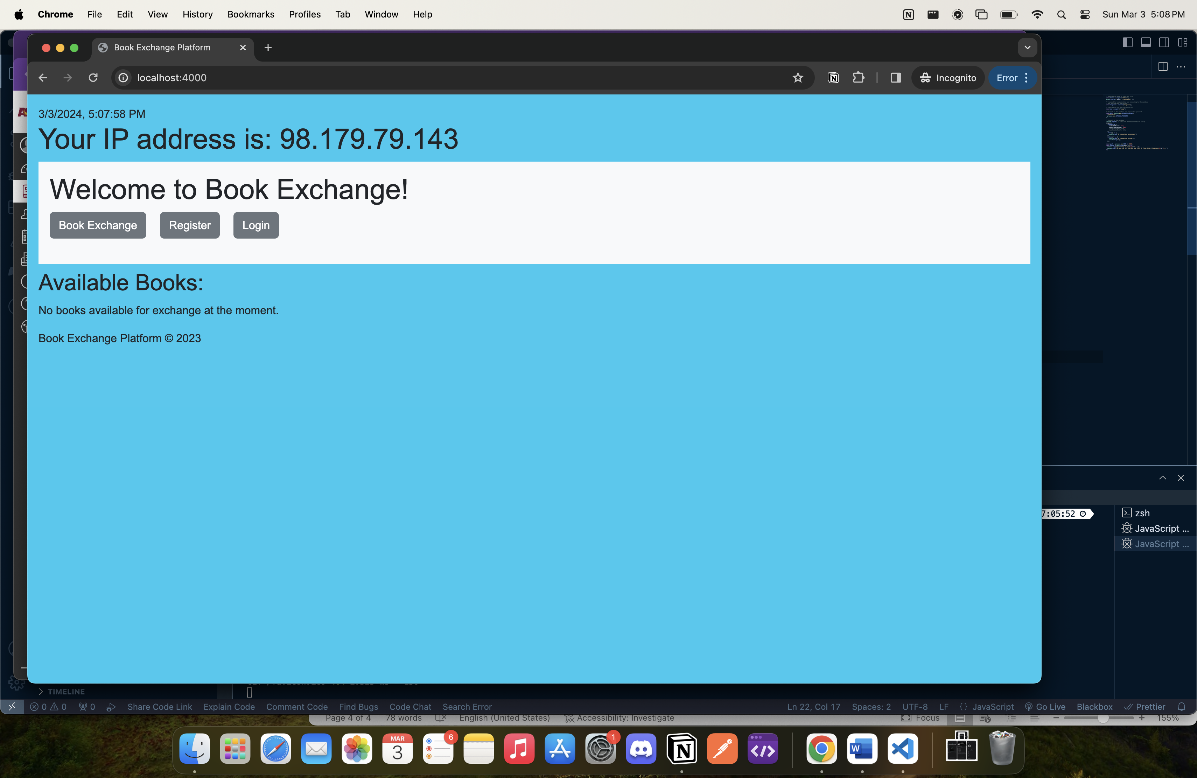

1. **Screenshot Requirement**: Screenshot of the "Add New Book Exchange" page and the login screen.

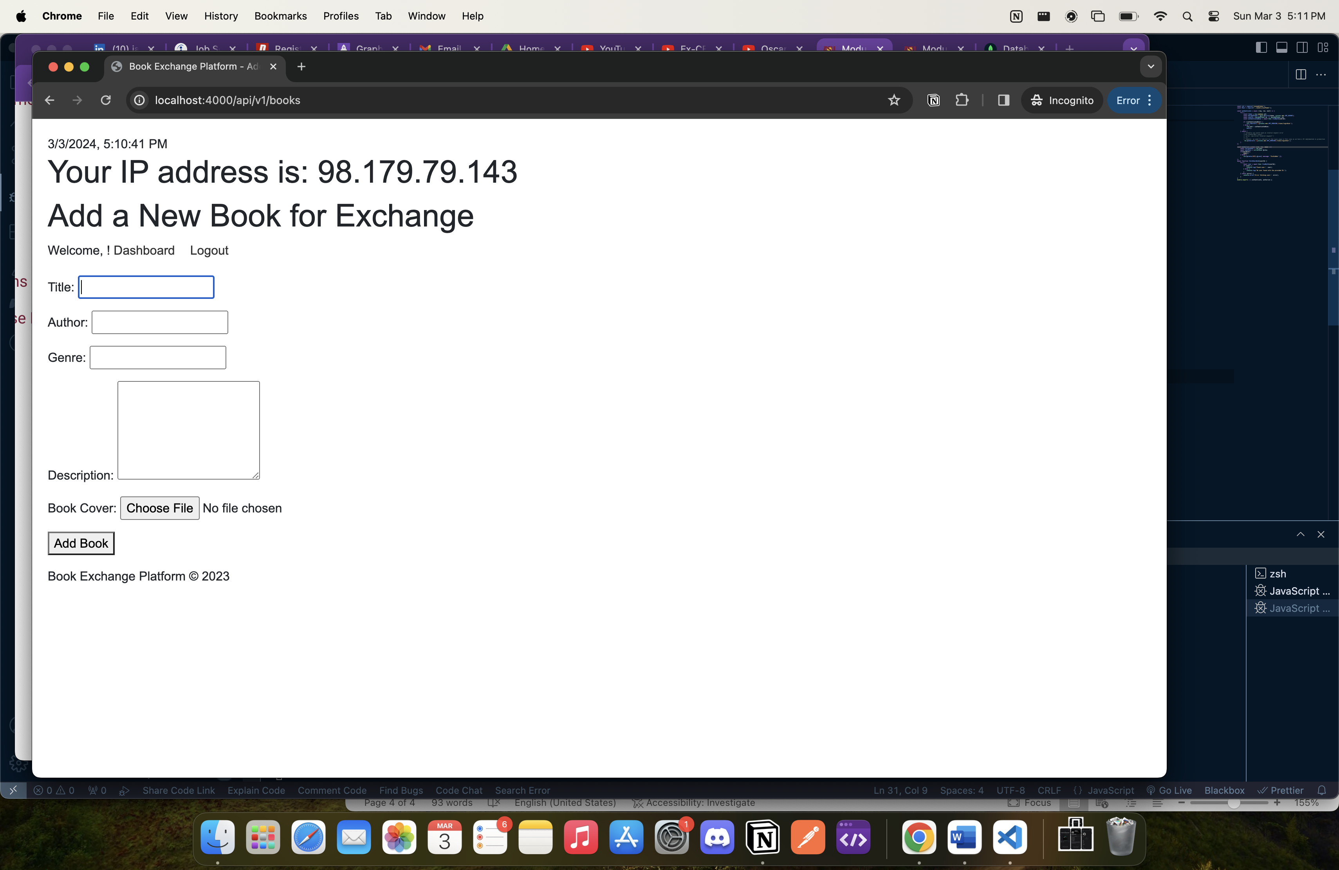

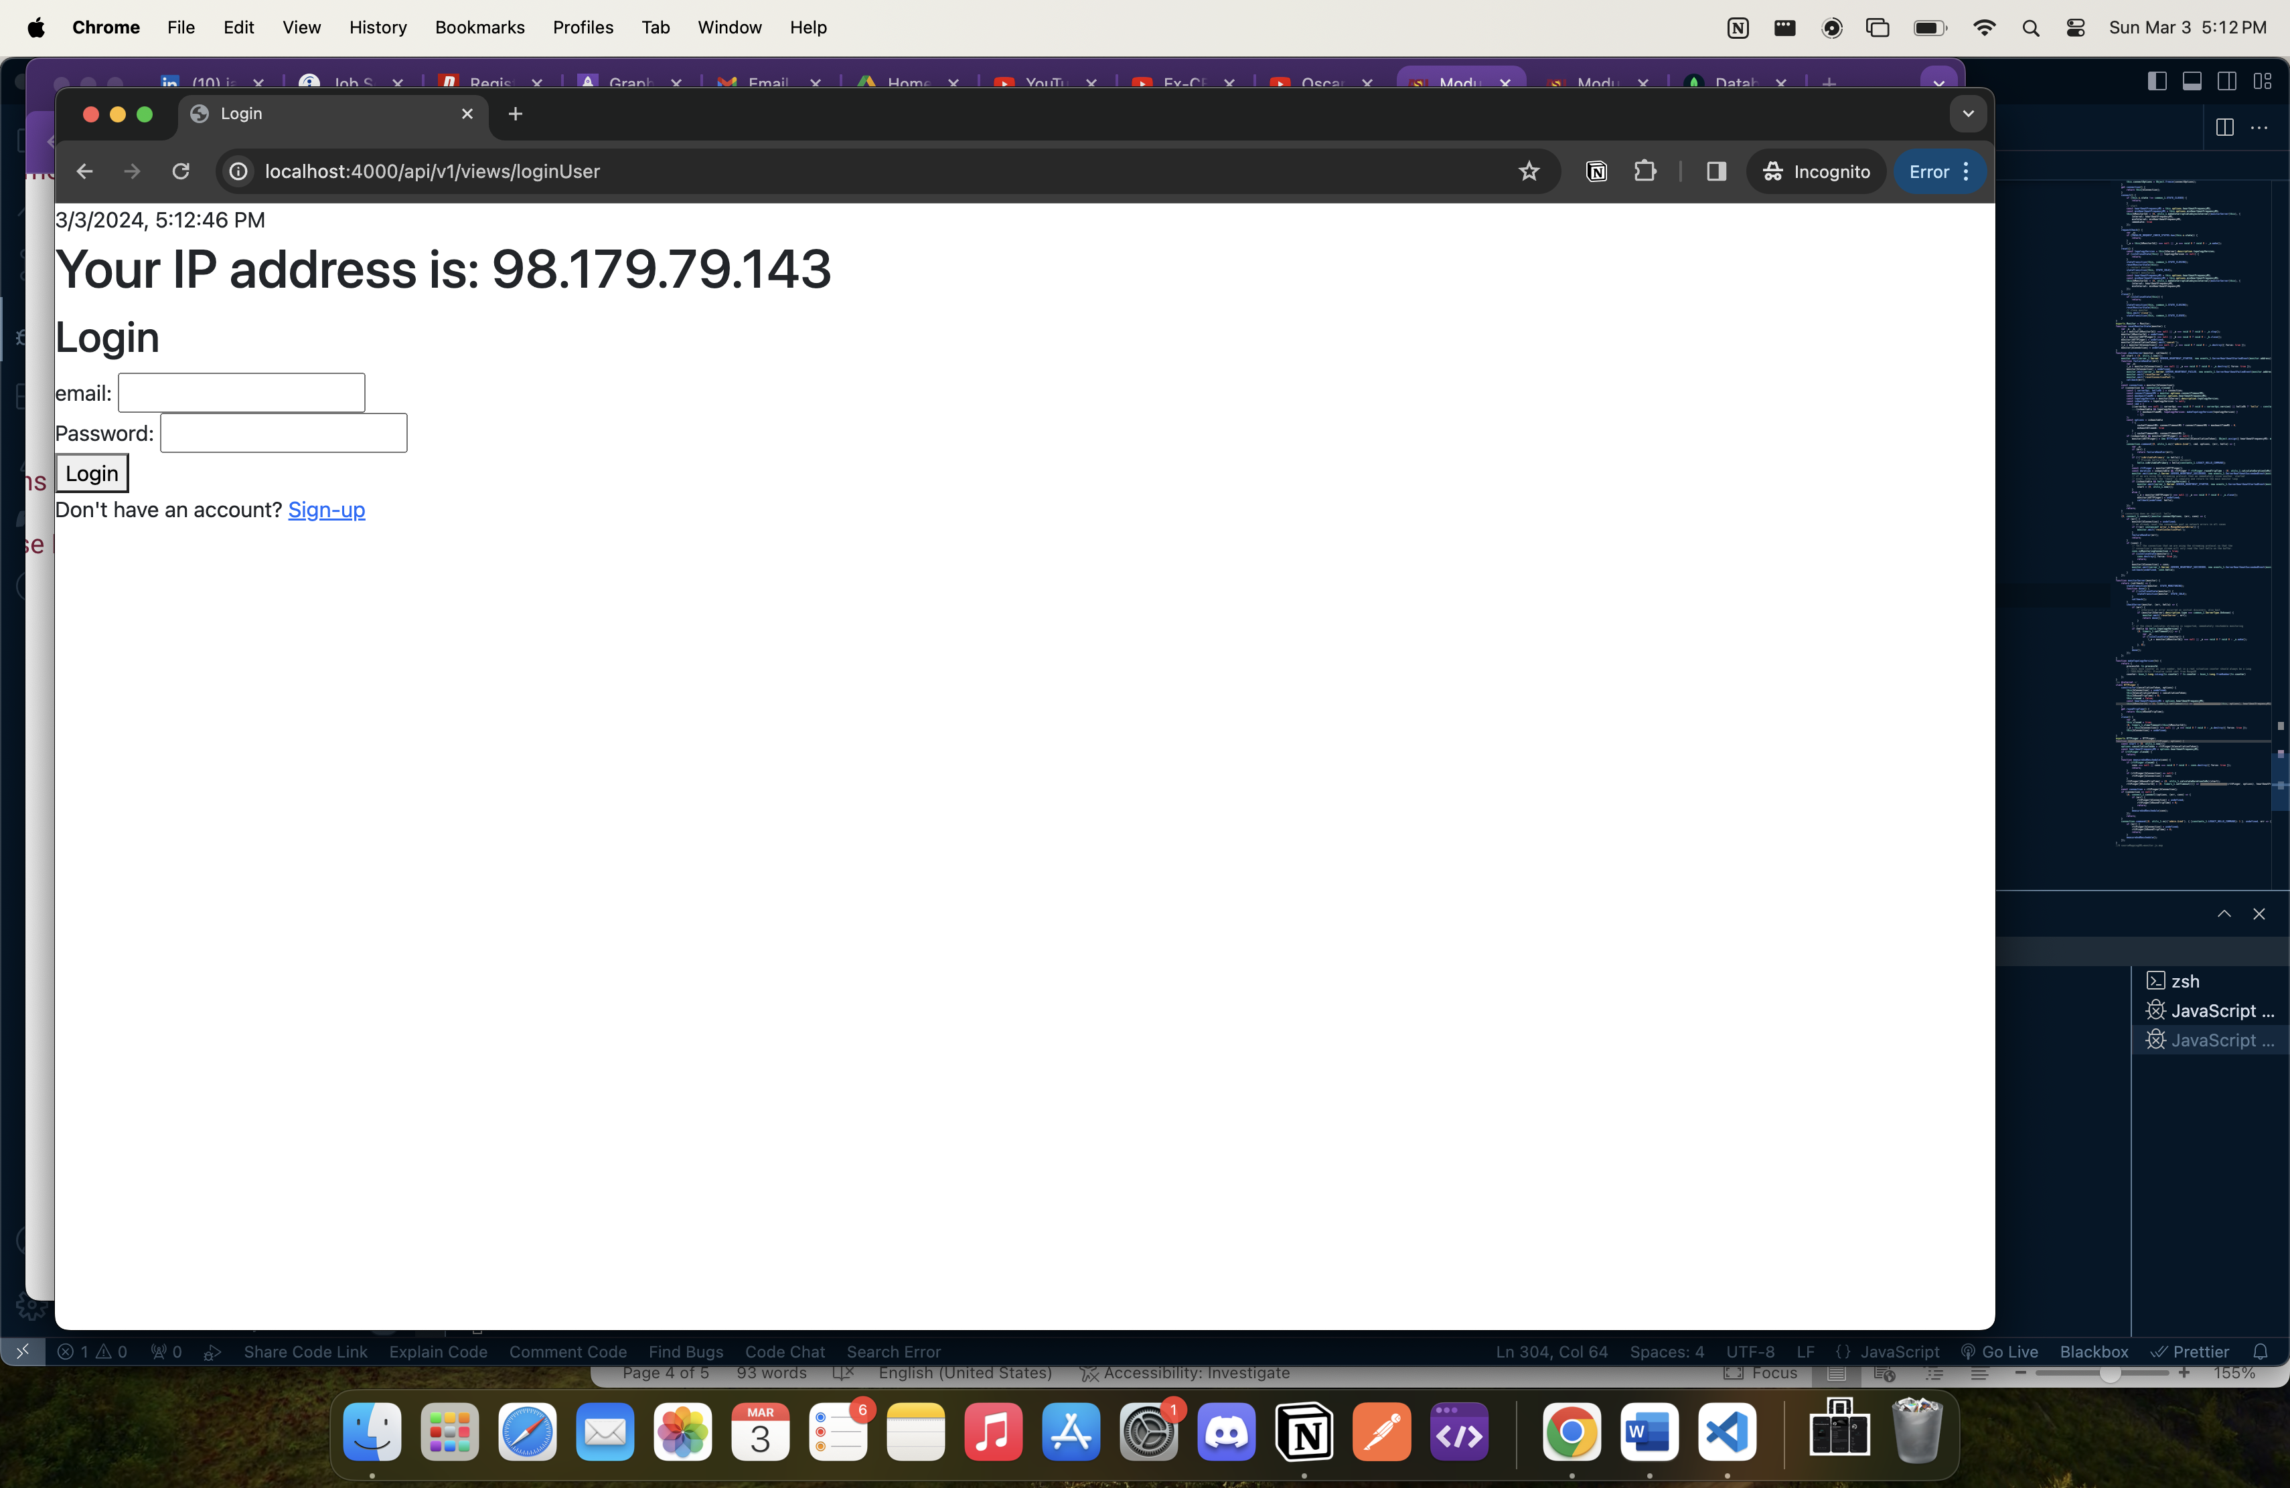

1. **Screenshot Requirement**: "Add New Book Exchange" page, indicating access to protected resources.

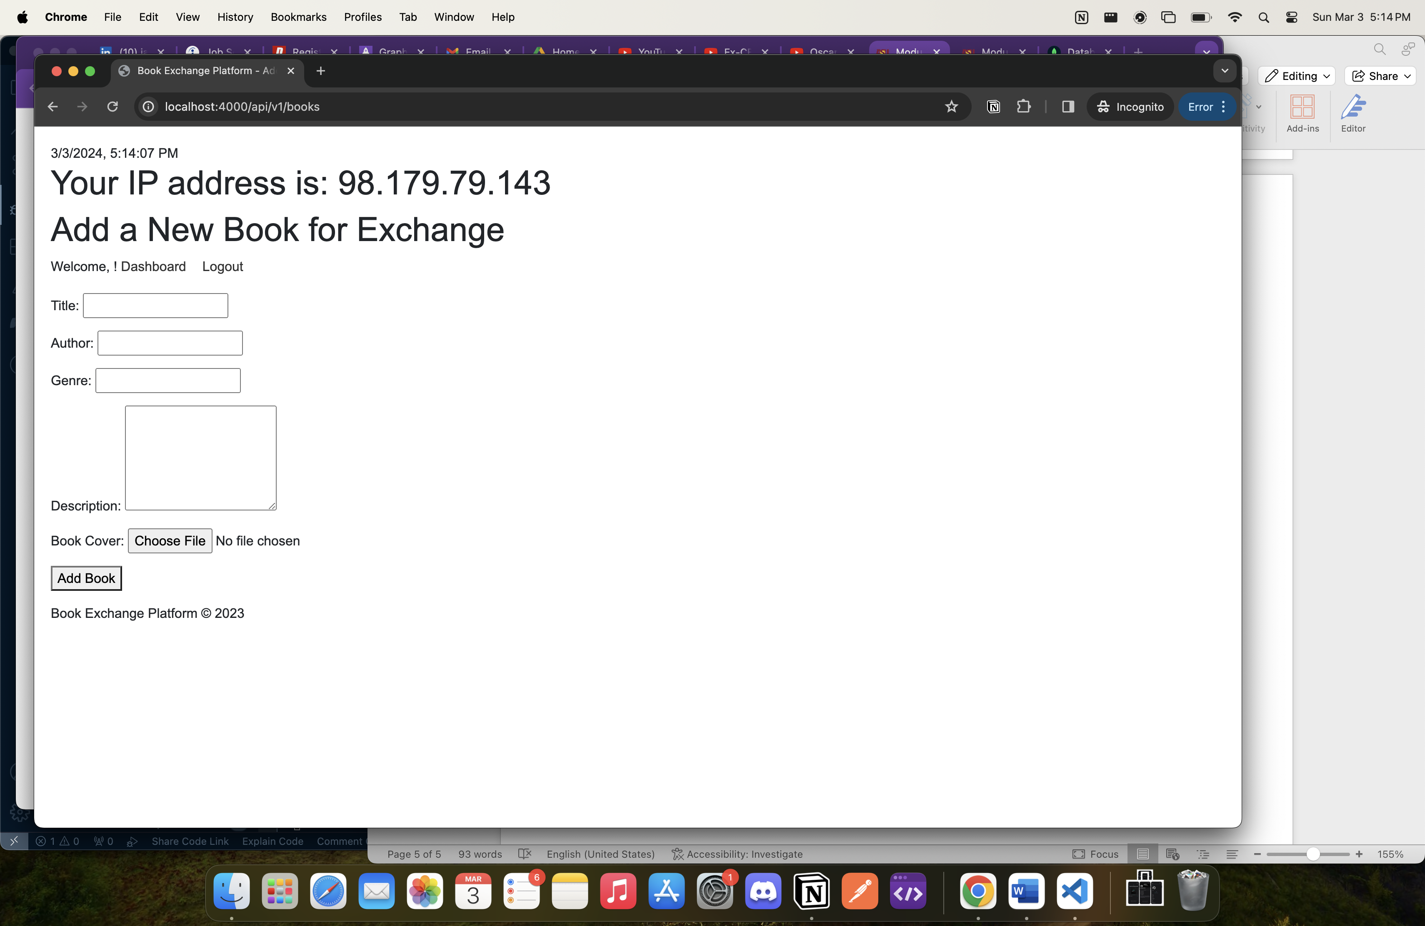

1. **Screenshot Requirement:** Terminal confirming the application has been stopped and restarted.

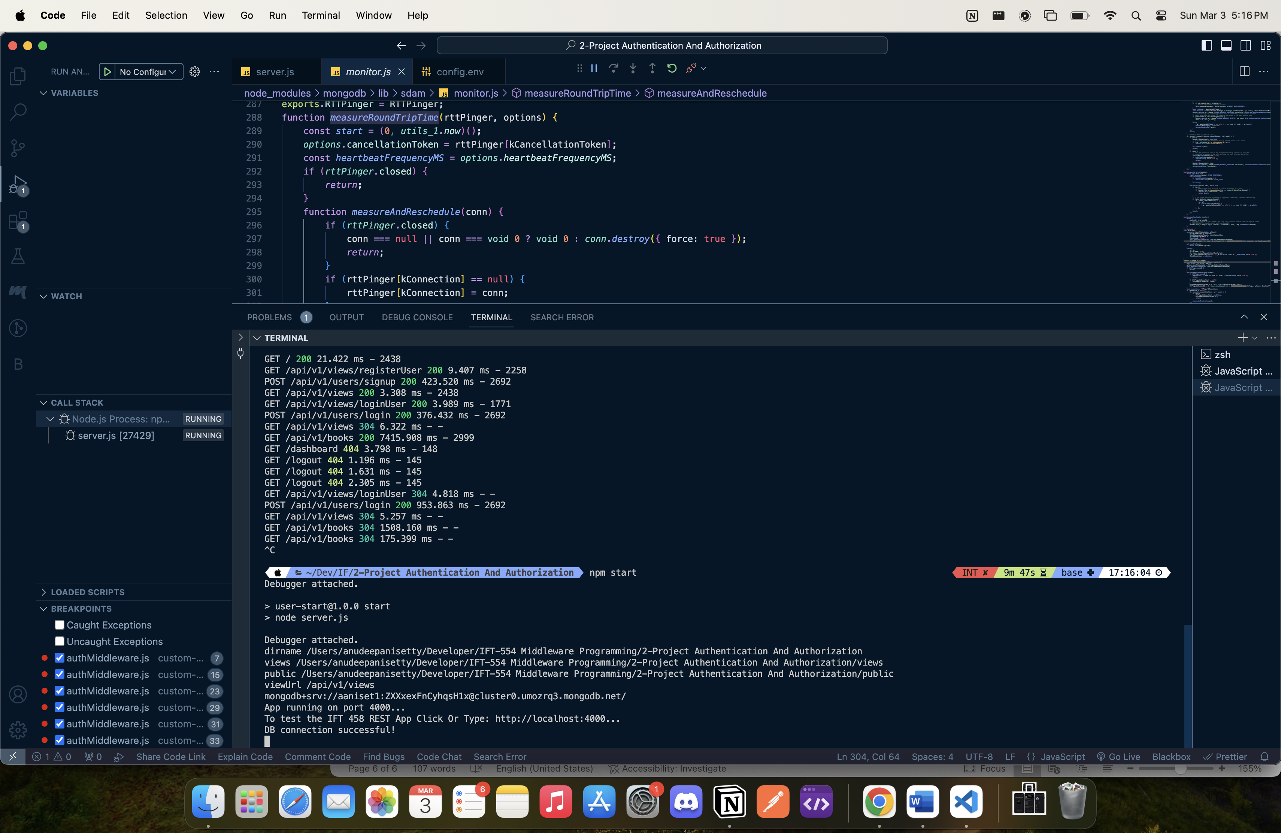

1. **Screenshot Requirement:** Direct access to the "Add New Book Exchange" UI, showing session persistence.

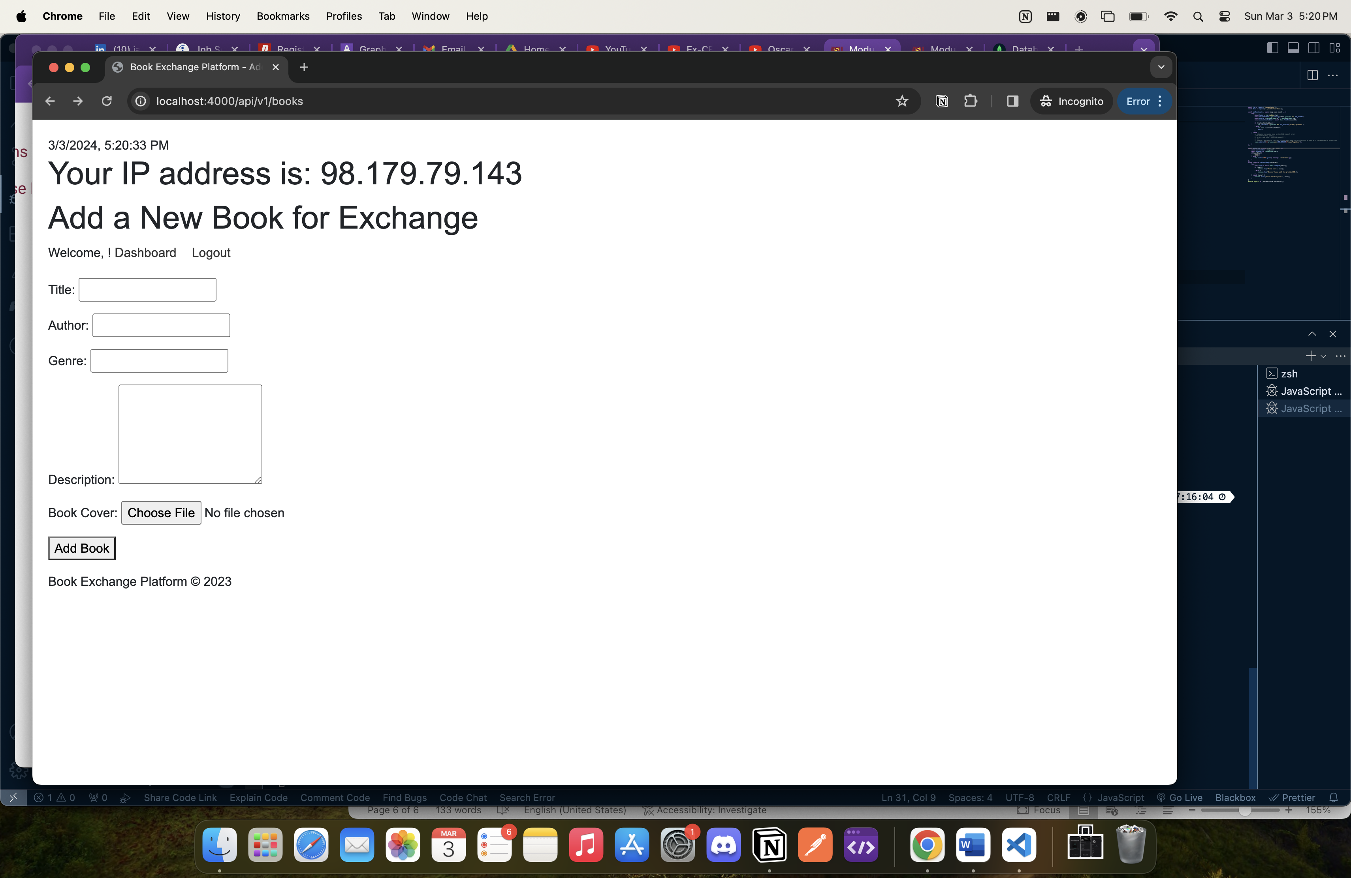

1. **Screenshot Requirement**: JWT token data and payload verification on jwt.io.

